IOT- ENABLED PRECISION AGRICULTURE

A PROJECT REPORT

Submitted by

DHODDAM REDDY MAHESH REDDY [Reg No:RA2011004020146] MALLELA REDDY KIRAN [Reg No:RA2011004020163] YASWANTH GUTLAPALLI [Reg No:RA2011004020162]

Under the guidance of

Ms Alice Linsie. A

(Assistant Professor, Department of Electronics and Communication & Engineering)

in partial fulfilment for the award of the degree of

BACHELOR OF TECHNOLOGY

in

ELECTRONICS AND COMMUNICATION ENGINEERING

of

FACULTY OF ENGINEERING AND TECHNOLOGY



SRM INSTITUTE OF SCIENCE AND TECHNOLOGY

RAMAPURAM

MAY 2024

BONAFIDE CERTIFICATE

Certified that this project report titled “IOT - ENABLED PRECISION AGRICULTRE” is the bonafide work of “DHODDAM REDDY MAHESH REDDY [Reg No:RA2011004020146] MALLELA REDDY KIRAN [Reg No:RA2011004020163] YASWANTH GUTLAPALLI [Reg No:RA2011004020162] who carried out the project work under my supervision as a batch. Certified further, that to the best of my knowledge the work reported herein does not form any other project report on the basis of which a degree or award was conferred on an earlier occasion for this or any other candidate.

Date : Project Supervisor Head of the Department

Submitted for University Examination held on in the Department of Electronics and Communication Engineering, SRM Institute of Science and Technology, Ramapuram .

Date: Internal Examiner External Examiner

Declaration

We hereby declare that the work presented in this report entitled “IOT-Enabled Precision Agriculture” in partial fulfilment of the requirements for the award of the degree of Bachelor of Technology in Electronics and communication engineering submitted for the Degree of Bachelor of Technology is our original work as a team and the dissertation has not formed the basis of any degree, diploma, associateship or fellowship of similar other titles. It has not been submitted to any other University or institution for the award of any degree or diploma.

Place : Chennai
Date :

D.Mahesh Reddy [RA2011004020146]

M. Reddy Kiran [RA2011004020163]

G.V.Yaswanth Babu[RA2011004020162
Acknowledgement

We are expressing our deep sense of gratitude to our beloved chancellor Dr. T. R. PAARIVENDHAR, for providing us with the required infrastructure throughout the course.
We take this opportunity to extend our hearty thanks to our Chairman Dr. R. SHIVAKUMAR, SRM Ramapuram & Trichy Campus for his constant support.
We take this opportunity to extend our hearty thanks to our Co-Chairman Mr. S. NIRANJAN, SRM Ramapuram & Trichy Campus for his constant support.
We take this opportunity to extend our hearty thanks to our Dean Dr. M. MURALI KRISHA, Ph.D., for his constant support.
We convey our sincere thanks to our Head of the Department Dr. R. VANI, Ph.D., for his suggestions, interest, encouragement and support throughout the project.
We convey our sincere thanks to our Project coordinator Dr. JUDY SIMON Ph.D., for her suggestions, interest, encouragement and support throughout the project.
We express our heartfelt thanks to our guide MS.A.Alice Linsie M.E (Ph.D), Assistant Professor (Grade), for his sustained encouragement, and constant guidance throughout the project work.
We express our deepest gratitude to, our parents, Teaching and Non- Teaching faculties for their sustained encouragement, and constant support throughout m

TABLE OF CONTENTS 4
Chapter -1 1
1.1 Introduction 1
1.2 Objective 2
1.3 Abstract 3
Chapter 2 4
2.1 Literature review 4
2.2 IoT based smart agriculture 4
Chapter-3 8
3.1 Proposed system 8
3.2 Advantages 9
3.3Technologies used in proposed system 9
3.4Disadvantages 10
Chapter-4 12
4.1 Block Diagram 12
Chapter – 5 13
5.1 Algorithms 13
Chapter- 6 14
6.1 Requirements 14
Chapter- 7 20
7.1Arduino s3v3 new features 20
7.2Applications 25
7.3Specifications 32
7.4 Application 32
7.5 Working Principle 38
7.6 Future work 39
Chapter-8 40
8.1 Automation function by Sensor 40
Chapter- 9 43
9.1Conclusion 43

Chapter -1

INTRODUCTION
Agriculture forms the backbone of our sustenance, and optimizing crop growth conditions is pivotal for ensuring food security. Traditional farming methods often lack precision in monitoring and maintaining crucial growth parameters for crops. The Smart Farming System Using IoT aims to address this challenge by leveraging sensor technology and IoT connectivity. The system integrates various sensors such as soil moisture, ultrasonic, DHT11, and LDR to gather essential data related to plant growth, soil moisture levels, temperature, and light intensity. These sensors interface with a microcontroller, which processes the data and communicates with an IoT platform. The IoT integration enables farmers to remotely monitor and control the conditions essential for optimal crop growth. Furthermore, the system incorporates a buzzer alert mechanism to notify farmers in real-time of any unfavourable conditions detected, allowing swift corrective actions. This project endeavours to revolutionize traditional farming practices by providing a smart, automated solution for efficient and effective crop cultivation. In this modern world, most of the farmer lack proper knowledge regarding farming and agriculture making it more erratic. Most part of farming and agricultural related activities are based on prediction and forecasting. When it fails, the farmers have to bear huge losses and some end up committing suicide. Since we are aware of the benefit of quality of soil and air, irrigational and in the growth of crops such parameters such as temperature, moisture cannot be neglected. Internet of Things was introduced in 2009 and it aims in incorporating all gadgets and devices to the web. “The Internet of Thing” is changing every second. IoT enhances our lives in terms of business; medical-health and society by modifying products which are IoT based making our life easier. It is predicted that by 2020, ‘50 billion devices will be connected to the web and the market will be worth of $14 Tintern of thing is an emerging topic of technical, social and economical development. Products like consumer items, big machineries, vehicles, mechanical and utility segment, sensors and others are connected to internet availability giving necessary information that guarantee to change the manner in which we work making our life simpler. There are five hottest topics of computer in this modern world. These are IoT, Big Data, Cloud Computing, Data Mining and Cyber Security. IoT is one from this topic and this is mostly related to device. It is advance automation and analytic system which is based on physical device. IoT system is unique from rest of the system and is more flexible since it enable many automate features and value. These devices mostly use sensors, AI, and other electronic device. It is upcoming topic in computer world and they are not world widely in used. Some are under implementation and some are under observation. The Second Green Revolution-After the world war, farming spared in excess of a billion people from starvation. Presently, a second upheaval, manufactured generally on advances that contain the Internet of Things, guarantees to make the ranch of things to come more beneficial and effective. Technologies such as sensor and monitor can help farmer to monitor crop quality continuous and more accurately. The following time for Smart Computation will be completely founded on Internet of Things (IoT). IoT has assumed a significant job of changing "Customary Technology" from homes to workplaces to "Cutting edge Everywhere Computing". It will make our life easier by making more efficient industries, smarter cities, connected car, etc. What is smart farm? Smart farming technology is the use of iot which connects devices such as Arduino with the sensor and performing task such as getting reading from the Arduino software and making decision according to it .it helps in the temperature, humidity, ph scale management. We also have some feature used by the farmers such as Robotics Data analytics using graph analysis Data mining using Markov chain Agricultural stick GPS sensing motors

OBJECTIVE
The primary objective of the project is to create an automated and efficient mechanism for monitoring and maintaining optimal growth conditions for crops. This involves integrating various sensors with a microcontroller to collect data on plant growth, soil moisture levels, temperature, and light conditions. The system aims to utilize IoT technology to enable remote monitoring and control, ensuring timely intervention and providing alerts for necessary actions to optimize crop yield. Agriculture is the most labour intensive a important field of occupation. Migration of labour from rural to urban affects agriculture. To enable farmers with technology. If farmers are well learned and have great knowledge about the advantages of using particular technologies, then they will have more interest in using technologies and doing farming work. They will educate other too about this things and the user will increase rapidly. Therefore, there is high chance of reducing the rural-urban migration which has many advantages such as solution to crowded population in urban area, solution to pollutions (soil, air, water ,noise ,etc). Noise pollution is one of the major problem in this urban cities. Increase output If farmer are well informed about farming activities like when to plant particular crops, vegetables and more. And also how much soil contains moisture and when to water. Then they will not make mistake is cropping and planting any things. Thus they will have greater output. Through IoT we can inform farmer about this things. Stabilize growth Stabilize growth means to maintain stable agricultural and other farming activities. Since there are high probability of facing food crisis, price crisis and most probably the economic crises. Farmers can stay stable during such crises if they have proper knowledge and method to do farming. With the use IoT we try to help farmers to solve many problems. Sustain farming Sustain farming means the system of plant and animals production that will last for the long term having minimal side effects. For example to satisfy human food we need to enhance environmental quality and naturals recourses but without any technologies and systems we cannot meet the demand of this. So IoT helps in meeting demand of this sustain farming. Precision Agriculture and Resource Optimization Smart farming aims to implement precision agriculture techniques through the precise application of resources such as water, fertilizers, and pesticides. IoT devices, including drones and automated machinery equipped with sensors and actuators, enable precise and targeted delivery of inputs based on crop requirements and environmental conditions. By employing variable rate technology (VRT) and automated irrigation systems, farmers can tailor inputs according to specific areas within their fields, optimizing resource utilization and minimizing waste. This targeted approach not only enhances crop quality and yield but also reduces environmental impact by mitigating the overuse of chemicals and water resources. Through sustainable farming practices enabled by IoT technology, farmers can achieve economic viability while preserving natural resources for future generations.

ABSTRACT
In recent years, agriculture has witnessed a significant transformation through the integration of cutting-edge technologies. One such revolutionary advancement is the implementation of Smart Farming utilizing the Internet of Things (IoT). This abstract delves into the intricate fabric of Smart Farming, elucidating its components, benefits, challenges, and future prospects. Smart Farming, an amalgamation of agricultural practices and IoT technologies, has emerged as a beacon of hope for addressing the pressing challenges faced by the agricultural sector. At its core, Smart Farming leverages IoT sensors, actuators, drones, and data analytics to optimize various farming processes. Through real-time monitoring and data-driven insights, farmers can make informed decisions pertaining to irrigation, fertilization, pest control, and overall crop management. The key components of Smart Farming include IoT sensors capable of collecting a myriad of data points such as soil moisture, temperature, humidity, and crop growth status. These sensors are strategically deployed across the farm to ensure comprehensive data acquisition. Subsequently, this data is transmitted to a centralized IoT platform where advanced analytics algorithms process the information, providing actionable insights to farmers. One of the primary benefits of Smart Farming is its ability to enhance resource efficiency. By precisely monitoring soil conditions and weather patterns, farmers can optimize irrigation schedules, thereby conserving water resources. Furthermore, targeted application of fertilizers and pesticides minimizes wastage and reduces environmental impact. The integration of IoT-enabled devices also facilitates predictive maintenance of farming equipment, ensuring optimal performance and longevity. Moreover, Smart Farming empowers farmers with unprecedented levels of control and visibility over their operations. Through intuitive dashboards and mobile applications, farmers can remotely monitor their crops and receive alerts regarding any anomalies or deviations from desired parameters. This real-time monitoring capability enables proactive intervention, mitigating potential risks and maximizing yields. However, despite its immense potential, Smart Farming encounters several challenges that warrant attention. Chief among these challenges is the issue of data security and privacy. As vast amounts of sensitive agricultural data are generated and transmitted, ensuring robust cybersecurity measures becomes imperative to safeguard against potential cyber threats and data breaches. Additionally, the high initial costs associated with implementing IoT infrastructure pose a barrier to adoption, particularly for small-scale farmers with limited financial resources. Looking ahead, the future of Smart Farming holds great promise fuelled by ongoing technological advancements. The proliferation of low-cost IoT sensors, coupled with advancements in artificial intelligence and machine learning, is poised to revolutionize agricultural practices further. Emerging technologies such as edge computing and blockchain offer novel solutions to enhance data processing efficiency and ensure data integrity within the agricultural ecosystem. In conclusion, Smart Farming leveraging IoT technologies represents a paradigm shift in modern agriculture, offering a holistic approach to sustainable farming practices. By harnessing the power of real-time data analytics and remote monitoring, Smart Farming enables farmers to optimize resource utilization, increase productivity, and mitigate environmental impact. While challenges persist, concerted efforts towards addressing these challenges coupled with ongoing technological innovation promise to propel Smart Farming towards a greener, more resilient future for agriculture.

Chapter- 2

LITERATURE REVIEW

IoT BASED SMART AGRICULTURE [1]

“Prof. Nikesh Gondchawar & Dr. R. S. Kawitkar, Electronics and communication, Sinhgad college of Engineering), Pune, India”
Publication date: June 2016 Integrated system deal with all elements influencing the profitability. The method aims in making horticulture excellent by efficiently utilizing computerization and IoT which uses GPS based remote controlled robots to perform field work such as weeding, splashing, dampness detecting, winged creature and creature startling, keeping carefulness, and so forth .Excellent watering system with keen control and smart leadership depend on exact constant field information. It additionally incorporates keen distribution centre, for example, temperature upkeep, dampness support and burglary discovery in the stockroom by Controlling every of these activities will be finished by any remote gadget / PC associated with Internet and the actions will be performed by interfacing sensors, ZigBee modules, camera and actuators with small scale controller and raspberry pi. Demerits by these projects are: Its expensive to use in actual field although it’s automotive and quick process. It causes weakening of radio recurrence (RF) signals by the organization of sensors dirt.Farmers would assess plant growth, soil moisture, and environmental conditions through visual inspection and periodic manual measurements. Irrigation scheduling was often based on regular intervals or personal experience rather than precise data-driven decisions. The absence of automated systems led to inefficiencies in resource utilization and delayed responses to changing conditions, impacting crop yield. The integration of advanced sensor technologies, IoT, and automation, as proposed in the Smart Farming System, revolutionized this traditional approach by enabling real-time data collection, remote monitoring, and timely interventions to optimize crop growth. It uses sensors that check different conditions of environmental factors like water level, humidity, and temp. etc., the processor along with IC-S8817BS and wireless transceiver module with Zigbee protocol is used. The field condition is sent to the farmer via mobile text messages and email from the experts. With this system SN fails and energy are managed efficiently. Zigbee technology is used which sometimes lack in range of communication. A system is proposed for green agriculture using Zigbee technologies. This model performs data processor, trans. and receiving function. The aim of the project is to understand smart farming system using green house, where efficiency of the system is to manage the environmental factors and decrease the faming overall cost and to save energy. Here it uses (BS structure and cc2530) which acts like processing chip for wireless sensor node. It uses Linux Operating system and the cortex A8 processor as a core. The design is all about remote intelligent monitoring and control of green house which replace the tradition wired smart house technology to wireless. It also reduce man power cost. A system is proposed for plant growth which can be monitored using thermal using Monitor.
IOT BASED SMART CROP MONITORING IN FARM LAND[2]
Naveen Balaji.G ,Nandhini.V , Mithra.S , Priya .N , Naveena. R- Assistant Professor, Department of ECE, SNS College of Technology, Coimbatore, TN – INDIA. - UG Student, Department of ECE, SNS College of Technology, TN – INDIA.” Publication: November 2018
It uses sensors that check different conditions of environmental factors like water level, humidity, and temp. etc., the processor along with IC-S8817BS and wireless transceiver module with Zigbee protocol is used. The field condition is sent to the farmer via mobile text messages and email from the experts. With this system SN fails and energy are managed efficiently. Zigbee technology is used which sometimes lack in range of communication. A system is proposed for green agriculture using Zigbee technologies. This model performs data processor, trans. and receiving function. The aim of the project is to understand smart farming system using green house, where efficiency of the system is to manage the environmental factors and decrease the faming overall cost and to save energy. Here it uses (BS structure and cc2530) which acts like processing chip for wireless sensor node. It uses Linux Operating system and the cortex A8 processor as a core. The design is all about remote intelligent monitoring and control of green house which replace the tradition wired smart house technology to wireless. It also reduce man power cost. A system is proposed for plant growth which can be monitored using thermal imaging technique. Here the irrigation temperature distribution measurement (ITDM) technique has been implied. In real time the thermal images comprising of both low and high temperature ITDM values gives better irrigation. Thermal imaging can provide temperature value of all pixels in the field when compared to thermometry which only provides an average value. For temperature which is very close in range, thermal imaging leads to inaccurate information so that the objects can become in differentiable. A method to evaluate the use of wireless sensor network used in automating irrigation and data are sent to the web application server through communicating wireless. 9 The sensors are used to sense the temperature, humidity, moisture for crop monitoring. The irrigation is automated when the sensor reading goes below the threshold values. The farmer is regularly intimated with the field conditions. It also explained that in greenhouses, intensity of light can be controlled and automated in addition to irrigation. Here, the prediction of crop water requirement is not efficient.
Smart Farming using Internet of Thing[3]
“ Rathinkumar. H. Kothiya Department of Information Technology, Chandubhai S. Patel Institute of Technology, Charusat University, Anand, Gujarat, India.” 11 “Karan L. Patel Department of Information Technology, Chandubhai S. Patel Institute of Technology, Charusat University, Anand, Gujarat, India.” “Prof. Hardik S. Jayswal (Research Guide) Assistant Professor, Department of Information Technology, Chandubhai S. Patel Institute of Technology, Charusat University, Anand, Gujarat, India.” Publication: November 2015
This aims in the equipment of different sensors for measuring environmental parameters required for the growth of crops. It includes node MCU and different sensors for executing and performing the whole process. The features used in this system is to gather all the environmental data and give accurate data to the farmers so that they can take most efficient decision related to farming. The system will perform tasks such as sensing the soil moisture, temperature, and humidity. It also indicates water level, detecting an intruder in the field and performing automation functions i.e switching an electric motor on/off manually. The system which is proposed has been tested, monitors the reading and obtain satisfying results which will enable the system to be very useful in smart farming. The sensors give reading such as the temperature reading, humidity reading, soil quality and water- level. It gives automation setting such as fan when the temperature is high giving status on and off and motor for sending water to plants.
IoT based smart sensors agriculture stick for live temperature and moisture monitoring.[4]
Anand Nayyar & Vikram Puri (Duy Tan University) Publication: November 12, 2018
This aims in giving an efficient monitoring of environment which will help the farmers to do smart farming increasing their overall yield and quality of products. The Agriculture stick being proposed in these project is integrated with Arduino Technology, Breadboard interfaced with various sensors providing live data feed online from Thingsspeak.com. This project gives 98% of the accurate data using the live agricultural stick tested on Live Agriculture Fields.
Management of crop water
To perform agriculture activities in an efficient way, adequate water is needed. In this approach the agriculture IoT is interfaced with Web Map Service (WMS) and Sensor Observation Service (SOS) to ensure water is properly managed for irrigation which in turn reduces water wastage.
Precision Agriculture
The weather information provided by this method should be high so that it reduces the chances of crop damage. Here agriculture IoT ensures in time delivery of real time data in terms of weather forecasting, soil quality, labour cost and much more to the farmers.
IPM/C -Integrated Pest Management/Control
In this, agriculture IoT systems assures that farmers with accurate environmental data via proper live data monitoring of temperature, moisture, growth of the plants and level of pests so that proper care can be given during production.
Food production & Safety agriculture
It accurately monitors various factors like temperature of warehouse, shipping transportation management system and integrates cloud based recording systems.
Other projects implemented till date are
a) the phenome project using open IoT
b) class equipment
c) precision hawk’s ova sensor platform
d) clean grow’s carbon using nanotube probe
e) tempeh’s wireless sensor monitoring.
SMART FARMING USING IOT[5]
“Hariharr C Punjabi, Sanket Agarwal, Vivek Khithani and Venkatesh Muddaliar” Student, Department of ECE & Telecom, VESIT Mumbai University, Mumbai, Maharashtra, India “Mrugendra Vasmatkar” Assistant Professor, Department of Electronics and Telecommunications, VESIT Mumbai University, Mumbai, Maharashtra, India Publication : November 2015
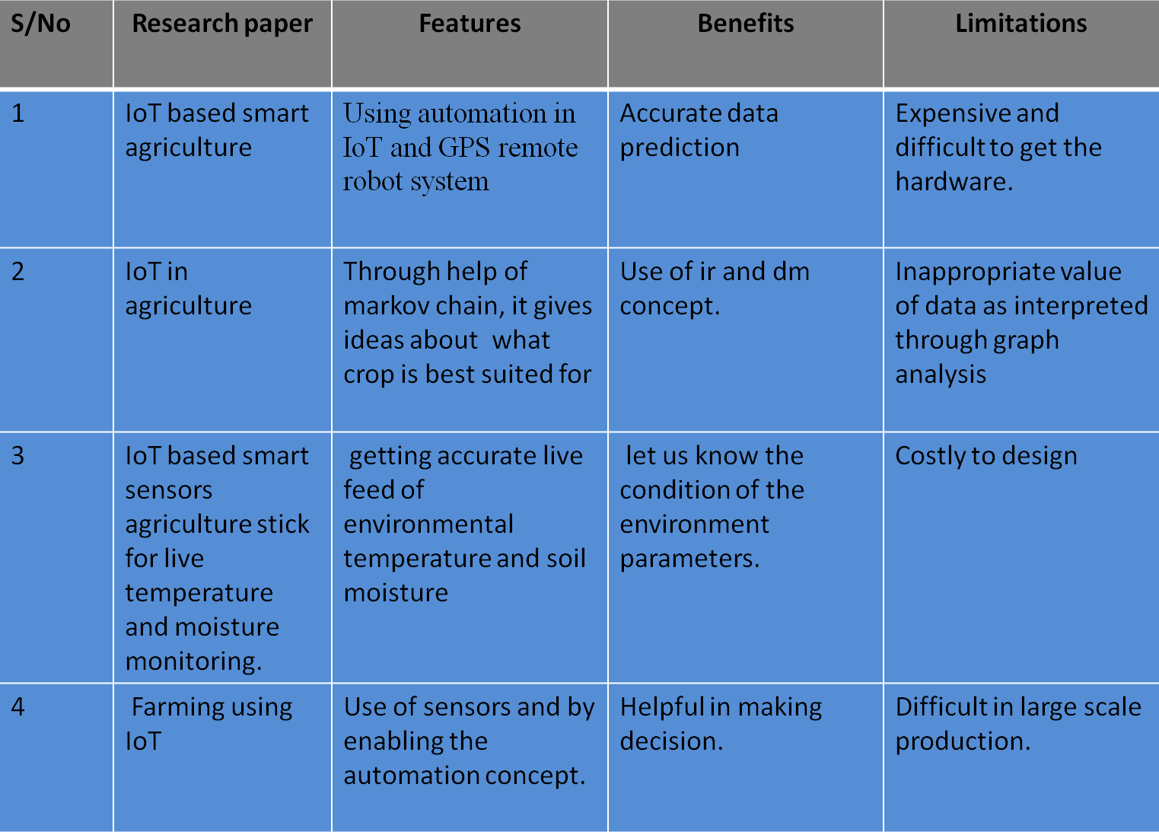
In this paper it mainly focuses in simple irrigation using IoT technologies. It uses the concept of iot and data mining. it solves the current problem of the farming methodologies and provide with the practical solutions. It uses features like GSM module which comes with the idea of updating farmer with the live condition of farm on the mobile device and present using graphical analysis.it also evaluates performance by using simple temperature sensing device

This process makes the work hand and convenient. It also reduce the effort for human to go to the actual farm and monitor it manually From the research papers we have referred, we have considered features like message alert features in WhatsApp using raspberry pi, getting reading from the sensors from Arduino IDE and making decisions according to it.

Chapter-3

PROPOSED SYSTEM
The proposed Smart Farming System integrates various cutting-edge technologies, including soil moisture sensors, ultrasonic sensors, DHT11, LDR, microcontrollers, and IoT. This system aims to automate and optimize crop growth conditions by continuously monitoring crucial parameters such as soil moisture levels, plant growth, ambient light, and temperature. The sensors collect real-time data, which is processed by the microcontroller, enabling timely and precise decision-making. The incorporation of IoT facilitates remote monitoring and control, allowing farmers to access and manage the farm conditions from anywhere. Alerts through a buzzer system promptly notify farmers in case of unfavourable conditions, enabling swift interventions and optimizing crop yield.
In the realm of ultramodern husbandry, the integration of slice- edge technologies has revolutionized traditional husbandry practices, giving rise to innovative results like the Smart Farming System. This proposed system stands at the van of agrarian advancement, seamlessly blending colourful technologies to produce an effective and sustainable approach to crop civilization. At its core, the Smart Farming System harnesses the power of detectors, microcontrollers, and IoT (Internet of effects) to cover and optimize pivotal parameters essential for crop growth. One of the crucial factors of this system is the application of soil humidity detectors, which give real- time data on the humidity situations in the soil. By continuously covering soil humidity, growers can insure that crops admit acceptable hydration, thereby promoting optimal growth and yield. also, ultrasonic detectors are employed to gauge factory growth, enabling growers to track the development of crops with perfection. This data, combined with information from other detectors similar as the DHT11 for temperature and moisture monitoring, and LDR for ambient light discovery, forms a comprehensive understanding of the environmental conditions girding the crops. The heart of the Smart Farming System lies in the microcontroller, which serves as the central processing unit for the collected detector data. Through sophisticated algorithms, the microcontroller analyses the incoming data in real- time, furnishing precious perceptivity into the health and status of the crops. This logical capability empowers growers to make informed opinions instantly, allowing for timely interventions when necessary. likewise, the integration of IoT technology enhances the functionality of the system by enabling remote monitoring and control. growers can pierce real- time data and perceptivity from their granges through a stoner-friendly interface, accessible from any internet- enabled device. This remote availability not only enhances convenience but also enables visionary operation of ranch operations, indeed from a distance. In the event of inimical conditions or anomalies detected by the detectors, the Smart Farming System employs an alert medium to instantly notify growers. A buzzer system integrated into the setup serves as an immediate alert, icing that growers are notified of any issues taking their attention. This visionary approach enables nippy interventions, mollifying implicit pitfalls and optimizing crop yield. What sets the proposed Smart Farming System piecemeal is its holistic approach to crop civilization, integrating multiple technologies into a cohesive and effective frame. By using real- time data analytics and remote availability, this system empowers growers to make data- driven opinions, eventually enhancing productivity and sustainability in husbandry. In substance, the Smart Farming System represents a paradigm shift in agrarian practices, steering in a new period of perfection husbandry. Through the flawless integration of advanced technologies, this system not only optimizes crop growth conditions but also ensures the effective application of coffers, paving the way for a further sustainable future in husbandry.

ADVANTAGES

- Precision Agriculture: Integration of advanced sensors ensures precise monitoring of essential parameters like soil moisture, plant growth levels, light intensity, and temperature, allowing for accurate decision-making.
- Optimized Resource Management: Real-time data collection enables efficient resource usage, particularly water for irrigation, reducing wastage and ensuring crops receive the necessary amount of water.
- Timely Interventions: Continuous monitoring allows for immediate detection of unfavourable conditions, triggering prompt alerts through the buzzer system. This facilitates timely interventions to mitigate risks and optimize crop health.
- Remote Monitoring and Control: IoT integration enables farmers to remotely monitor and manage farm conditions from anywhere, providing flexibility and ease of management.
- Enhanced Crop Yield: By maintaining optimal growth conditions and swiftly addressing issues, the system aims to enhance crop yield, ensuring better productivity and economic outcomes for farmers. Smart farming using IoT offers unique advantages that revolutionize traditional agricultural practices. One key advantage lies in its ability to facilitate precision agriculture through the integration of advanced sensors. This ensures meticulous monitoring of crucial parameters such as soil moisture, plant growth levels, light intensity, and temperature. By providing precise data, farmers can make informed decisions, leading to optimized resource management. Real-time data collection allows for efficient utilization of resources, particularly water for irrigation, minimizing wastage and ensuring crops receive the exact amount needed for optimal growth. Moreover, the system enables timely interventions by continuously monitoring farm conditions and triggering alerts through buzzer systems. This swift response mechanism helps mitigate risks and optimize crop health, ultimately leading to enhanced yield. Additionally, IoT integration empowers farmers to remotely monitor and control farm conditions from anywhere, offering unparalleled flexibility and ease of management. By maintaining optimal growth conditions and addressing issues promptly, the smart farming system aims to significantly boost crop yield, ensuring better productivity and economic outcomes for farmers. Thus, the project's unique approach lies in its seamless integration of IoT technologies to streamline agricultural processes and maximize productivity sustainably.
TECHNOLOGIES USED IN PROPOSED SYSTEM
IoT (Internet of Things) Technology: Enables remote monitoring and control of agricultural parameters, facilitating efficient management of crop growth conditions.
Sensors: Various sensors including ultrasonic, soil moisture, DHT11, and LDR are utilized to collect real-time data on plant growth, soil moisture levels, temperature, and light intensity.
Microcontroller: Acts as the central processing unit, interfacing with sensors to collect data and controlling the system's operations based on predefined algorithms.
IoT Platform: Provides a centralized interface for farmers to remotely monitor and manage crop growth conditions, enabling timely interventions and adjustments.
Buzzer Alert Mechanism: Alerts farmers in real-time about unfavorable conditions detected by the sensors, prompting swift corrective actions to optimize crop yield.
Data Processing Algorithms: Algorithms are implemented within the microcontroller to process sensor data, analyze environmental conditions, and trigger appropriate responses or alerts.
IoT technology has revolutionized husbandry by enabling remote monitoring and control of colourful parameters critical for crop growth. This system utilizes a range of detectors to gather real- time data on factors similar as soil humidity, temperature, light intensity, and other environmental conditions. The crucial factors of this technology include
Detectors: colourful types of detectors are stationed throughout the agrarian field to collect data. These include - Ultrasonic detectors Used to measure distances, they can be employed for monitoring water situations in tanks or for detecting the presence of objects. - Soil humidity detectors Essential for assessing soil humidity situations, which are pivotal for determining irrigation requirements and precluding both overwatering and underwatering. - DHT11 detectors These detectors measure temperature and moisture, furnishing precious information on the environmental conditions within the growing area. – LDR ( Light Dependent Resistor) detectors Used for measuring light intensity, which is vital for understanding the quantum of sun reaching the crops and optimizing growth conditions consequently.
Microcontroller: This serves as the central processing unit of the system, responsible for uniting with the detectors to collect data and controlling colourful operations grounded on predefined algorithms. Generally used microcontrollers include Arduino, Raspberry Pi, or ESP8266/ ESP32.
Communication Module: To enable remote monitoring and control, the system generally incorporates a communication module similar as Wi- Fi, Bluetooth, Lora, or GSM/ GPRS. This allows the collected data to be transmitted to a central garçon or a stoner interface for analysis and decision- timber.
Selectors: In addition to monitoring, IoT systems in husbandry frequently include selectors to enable control over certain parameters. For case, irrigation systems can be controlled grounded on soil humidity data collected by the detectors.
Data Analysis and Visualization: The collected data is generally anatomized to gain perceptivity into crop health, optimize resource operation, and make informed opinions. Visualization tools similar as graphs, maps, and dashboards may be employed to present the data in a stoner-friendly manner. Overall, IoT technology in husbandry offers growers the capability to cover and manage crop growth conditions ever, leading to more
DISADVANTAGES
- Limited Precision: Manual monitoring and observation lacked precision and real-time accuracy in assessing plant growth, soil moisture, and environmental parameters. This imprecision could lead to suboptimal decision-making.
- Resource Inefficiency: Without accurate data, resources such as water for irrigation were often used inefficiently, potentially leading to overwatering or under-watering crops, impacting both yield and resource conservation.
- Delayed Responses: Manual monitoring meant delayed responses to changing conditions. By the time issues were identified through visual inspection, corrective actions might have been delayed, impacting crop health.
- Reliance on Experience: Decisions were often based on the farmer's experience and intuition rather than on concrete data. This reliance on subjective assessments could lead to inconsistencies and suboptimal outcomes.
- Risk of Crop Loss: Inability to promptly identify issues such as low soil moisture levels or other environmental stressors increased the risk of crop loss due to unfavourable conditions going unnoticed.

Chapter-4

Block Diagram

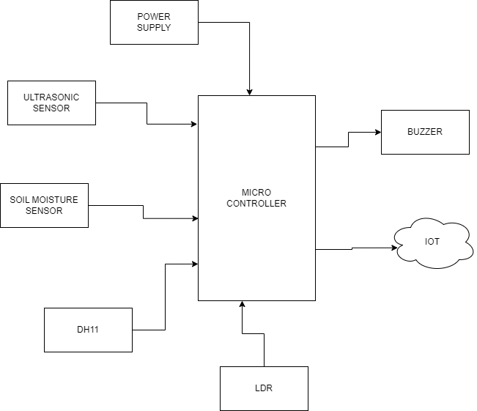

This block diagram illustrates the flow of data and control commands within a smart farming system using IoT technology. Sensors gather data from the farm environment, which is then transmitted wirelessly to the central control system. The central control system analyses this data and sends commands to actuators to optimize farm operations. Farmers can monitor and manage their farm remotely through a web or mobile application interface, with data potentially stored and processed in the cloud for further analysis and insights. Data collected by the central control system may be stored and processed in the cloud. Cloud platforms offer scalability, data redundancy, and accessibility from anywhere with an internet connection.

Chapter – 5

ALGORITHMS
Temperature sensor DTH11 Steps:
1. Assigning analog pin A5 to sensor
2. Store temperature in degree Celsius
3. Store temperature in Fahrenheit
4. Configuring sensor pin as input
5. Reading the value from sensor
6. Output voltage = (vout *500) / 1023;
7. Storing value in Degree Celsius
8. Temperature in Fahrenheit = (Vout*1.8) + 32 (Converting degree celsius to Fahrenheit)
9. Temperature display in Degree and Fahrenheit in the pc

Soil moisture Sensor
Steps :
1. Initialize serial communication at 9600 Bps.
2. Read the input on analog pin 0
3. Get the value you read

Chapter- 6

REQUIREMENTS

- SOFTWARE REQUIREMENTS:

- Arduino ide
- Embedded C
- IOT

- HARDWARE REQUIREMENTS:
- Microcontroller
- Soil moisture sensor
- Ultrasonic sensor
- Dht 11
- LDR
- Buzzer

HARDWARE MODULE:
NODE MCU
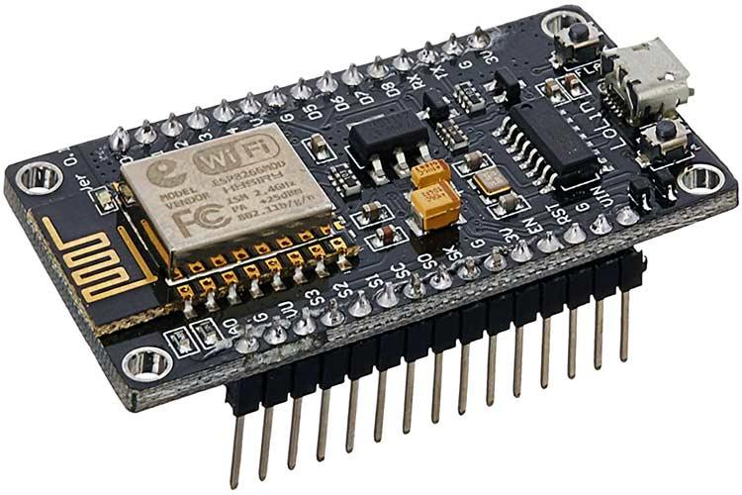

NodeMCU is an open-source Lua based firmware and development board specially targeted for IoT based Applications. It includes firmware that runs on the ESP8266 Wi-Fi SoC from Espressif Systems, and hardware which is based on the ESP-12 module.
NodeMCU Development Board Pinout Configuration
Pin Category | Name | Description
Power | Micro-USB, 3.3V, GND, Vin | Micro-USB: NodeMCU can be powered through the USB port  3.3V: Regulated 3.3V can be supplied to this pin to power the board  GND: Ground pins  Vin: External Power Supply
Control Pins | EN, RST | The pin and the button resets the microcontroller
Analog Pin | A0 | Used to measure analog voltage in the range of 0-3.3V
GPIO Pins | GPIO1 to GPIO16 | NodeMCU has 16 general purpose input-output pins on its board
SPI Pins | SD1, CMD, SD0, CLK | NodeMCU has four pins available for SPI communication.
UART Pins | TXD0, RXD0, TXD2, RXD2 | NodeMCU has two UART interfaces, UART0 (RXD0 & TXD0) and UART1 (RXD1 & TXD1). UART1 is used to upload the firmware/program.
I2C Pins |  | NodeMCU has I2C functionality support but due to the internal functionality of these pins, you have to find which pin is I2C.

NodeMCU ESP8266 Specifications & Features
- Microcontroller: Tensilica 32-bit RISC CPU Xtensa LX106
- Operating Voltage: 3.3V
- Input Voltage: 7-12V
- Digital I/O Pins (DIO): 16
- Analog Input Pins (ADC): 1
- UARTs: 1
- SPIs: 1
- I2Cs: 1
- Flash Memory: 4 MB
- SRAM: 64 KB
- Clock Speed: 80 MHz
- USB-TTL based on CP2102 is included onboard, Enabling Plug n Play
- PCB Antenna
- Small Sized module to fit smartly inside your IoT project

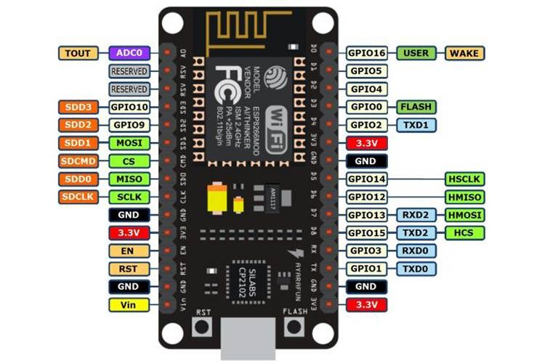
General Purpose Input/Output Interface (GPIO)
ESP8266EX has 17 GPIO pins which can be assigned to various functions by programming the appropriate registers. Each GPIO can be configured with internal pull-up or pull-down, or set to high impedance, and when configured as an input, the data are stored in software registers; the input can also be set to edge-trigger or level trigger CPU interrupts. In short, the IO pads are bidirectional, non-inverting and tristate, which includes input and output buffer with tristate control inputs. These pins can be multiplexed with other functions such as I2C, I2S, UART, PWM, IR Remote Control, etc.
Secure Digital Input/Output Interface (SDIO)
ESP8266EX has one Slave SDIO, the definitions of which are described below. 4-bit 25 MHz SDIO v1.1 and 4-bit 50 MHz SDIO v2.0 are supported.
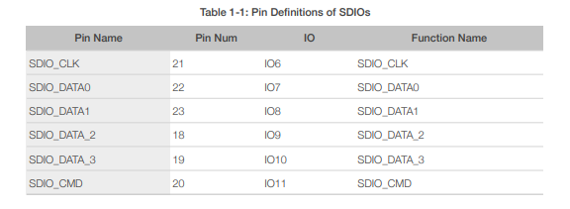
Serial Peripheral Interface (SPI/HSPI)
ESP8266EX has 3 SPIs.
One general Slave/Master SPI
One Slave SDIO/SPI
One general Slave/Master HSPI
Functions of all these pins can be implemented via hardware. The pin definitions are described as below.
General SPI (Master/Slave)
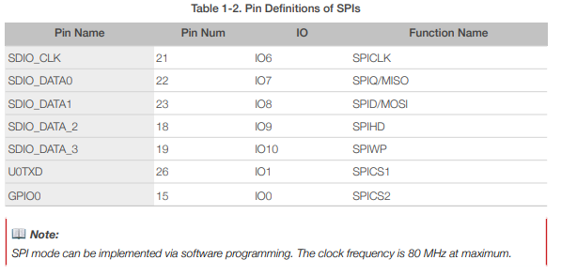
I2C Interface
ESP8266EX has one I2C used to connect with micro-controller and other peripheral equipments such as sensors. The pin definition of I2C is as below.Both I2C Master and I2C Slave are supported. I2C interface functionality can be realized via software programming, the clock frequency reaches 100 kHz at a maximum. It should be noted that I2C clock frequency should be higher than the slowest clock frequency of the slave device.
Universal Asynchronous Receiver Transmitter (UART) ESP8266EX has two UART interfaces UART0 and UART, the definitions are as below. Data transfers to/from UART interfaces can be implemented via hardware. The data transmission speed via UART interfaces reaches 115200 x 40 (4.5 Mbps). UART0 can be used for communication. It supports fluid control. Since UART1 features only data transmit signal (Tx), it is usually used for printing log.
Pulse-Width Modulation (PWM) ESP8266EX has four PWM output interfaces. They can be extended by users themselves. The pin definitions of the PWM interfaces are defined as below.The functionality of PWM interfaces can be implemented via software programming. For example, in the LED smart light demo, the function of PWM is realized by interruption of the timer, the minimum resolution reaches as much as 44 ns. PWM frequency range is adjustable from 1000 μs to 10000 μs, i.e., between 100Hz and 1 kHz. When the PWM frequency is 1 kHz, the duty ratio will be 1/22727, and over 14 bit resolution will be achieved at 1 kHz refresh rate.
Functional Overview This protocol uses the SDIO mode of the ESP8266 to communicate with other processor's SPI hosts. The electrical interface is connected through signal line No.4, including the SCLK, MOSI, MISO and interrupt signal No.1 in the SPI protocol (note: no CS signal). Downloading the ESP8266 SDIO can be different from downloading other programs. When the ESP8266 starts, the system reads the pin shared by the SPI interface and the SDIO interface by default. Therefore, the SDIO module communication protocol should be used. The ESP8266 should start in the SDIO mode, and then, the host will start the chip in the ESP8266 RAM through the SDIO downloaded programs. The majority of the programs that directly use CPU CACHE to call FLASH can be burnt to the FLASH chip connected to the HSPI interface beforehand. Data received or sent by the ESP8266 SDIO is processed directly by the DMA module that supports linked list index. The ESP8266 can receive and send the SDIO packets efficiently without using the CPU. It does so through the address the memory map linked list and re-transfer sketch, prior to interfacing outside voltage to ARE
Chapter- 7

ARDUINO S3v3 NEW FEATURES
- full viable with Shield Boards (Version 2 is the main Arduino Board not viable with Shield Boards as a result of ICSP header wrong position, and tall parts);
- AVcc LP channel to lessen commotion level on ADC;
- auto reset include;
- auto reset empower/impair jumper, to dodge not wanted reseting;
- arduinoDiecimila viable reset pin;
- pin13 locally available drove, with current limiter resistor;
- TX and RX locally available leds;
- power drove with suitable current limiter resistor (less 20mA of comsumption);

- jumper to impair sequential correspondence and to empower RX outer draw down resistor, to evade "RX skimming blunder". This element permits to utilize computerized pin0 and pin1 as an ordinary pin, when sequential correspondence isn't required;
- all comparative segments (diodes, semiconductors, leds, capacitors) has a similar board direction (to commits simpler to mount with less errors);
- no wires between cushions, more space between wires, bigger wires, bigger cushions (better for drawing, binding and penetrating, with no shortcircuits, patching extensions or open wires in erosion);
- just 3 wire spans;
- electrolitic capacitor (in sequential to TTL circuit) changed to bipolar sort (to keep away from rearranged voltage issue when sequential link isn't associated);
All jumpers are correct point type, to permit Shield Boards use.
SOIL SENSOR:
Below Figure shows an analog capacitive soil moisture sensor that measures the soil moisture levels by capacitive sensing. The capacitance varies according to the water contents present in the soil. Depending on the capacitance value, the voltage level varies from a minimum of 1.2V to a maximum of 3.0V. The capacitive soil moisture sensor is primarily used as they are made of a corrosion-resistant material giving it a long service life. The resistance is inversely proportional to the soil moisture: The amount of water in the soil determines conductivity. More water in the soil results in higher conductivity and hence offers lower resistance. The less water in the soil results in poor conductivity and hence the resistance is high.
- VCC pin is used for power
- A0 pin is an analog output
- D0 pin is a digital output
- GND pin is a Ground
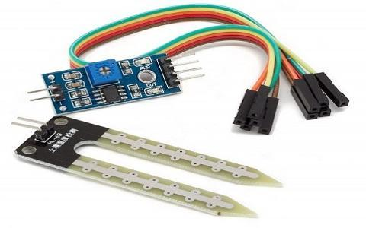
This module also includes a potentiometer that will fix the threshold value, & the value can be evaluated by the comparator-LM393. The LED will turn on/off based on the threshold value.

Working Principle:
This sensor mainly utilizes capacitance to gauge the water content of the soil (dielectric permittivity). The working of this sensor can be done by inserting this sensor into the earth and the status of the water content in the soil can be reported in the form of a percent.
This sensor makes it perfect to execute experiments within science courses like environmental science, agricultural science, biology, soil science, botany, and horticulture.
Specifications
The specification of this sensor includes the following.
- The required voltage for working is 5V
- The required current for working is <20mA
- Type of interface is analog
- The required working temperature of this sensor is 10°C~30°C
Soil Moisture Sensor Applications
The applications of moisture sensor include the following.
- Agriculture
- Landscape irrigation
- Research
- Simple sensors for gardeners

DHT-11
DHT11 humidity and temperature sensor is available as a sensor and as a module. The difference between this sensor and module is the pull-up resistor and a power-on LED. DHT11 is a relative humidity sensor. To measure the surrounding air this sensor uses a thermistor and a capacitive humidity sensor.
- DHT11:
This sensor is used here to monitor the humidity variation of the environment where the crops are cultivated. This is a digital sensor and measures the humidity value in percentage format.
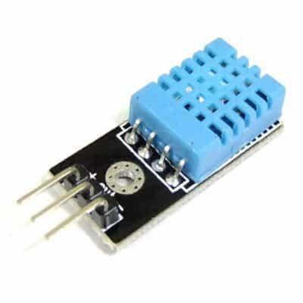Fig.DHT11 Sensor
DHT11 is a low-cost digital sensor for sensing temperature and humidity. This sensor can be easily interfaced with any micro-controller such as Arduino, Raspberry Pi etc… to measure humidity and temperature instantaneously.
Working
DHT11 sensor consists of a capacitive humidity sensing element and a thermistor for sensing temperature. The humidity sensing capacitor has two electrodes with a moisture holding substrate as a dielectric between them. Change in the capacitance value occurs with the change in humidity levels. The IC measure, process this changed resistance values and change them into digital form.For measuring temperature this sensor uses a Negative Temperature coefficient thermistor, which causes a decrease in its resistance value with increase in temperature. To get larger resistance value even for the smallest change in temperature, this sensor is usually made up of semiconductor ceramics or polymers.The temperature range of DHT11 is from 0 to 50 degree Celsius with a 2-degree accuracy. Humidity range of this sensor is from 20 to 80% with 5% accuracy. The sampling rate of this sensor is 1Hz .i.e. it gives one reading for every second. DHT11 is small in size with operating voltage from 3 to 5 volts. The maximum current used while measuring is 2.5mA.DHT11 sensor has four pins- VCC, GND, Data Pin and a not connected pin. A pull-up resistor of 5k to 10k ohms is provided for communication between sensor and micro-controller.

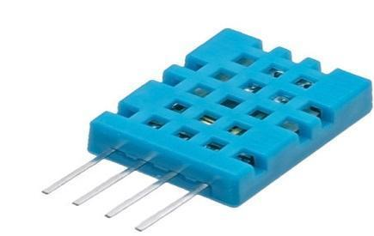
Fig. HUMIDITY (DHT11)
Working
- DHT11 uses only one wire for communication. The voltage levels with certain time value defines the logic one or logic zero on this pin.
- The communication process is divided in three steps, first is to send request to DHT11 sensor then sensor will send response pulse and then it starts sending data of total 40 bits to the microcontroller.
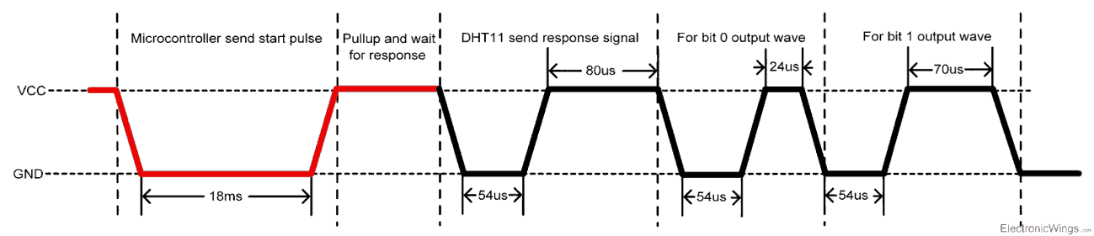
Communication process

Start pulse (Request)
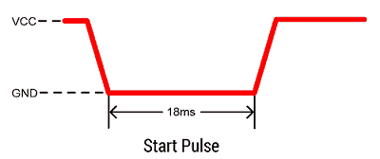
- To start communication with DHT11, first we should send the start pulse to the DHT11 sensor.
- To provide start pulse, pull down (low) the data pin minimum 18ms and then pull up, as shown in diag.
Response
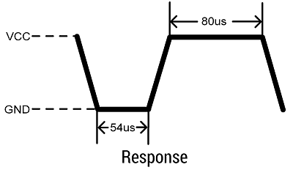
- After getting start pulse from, DHT11 sensor sends the response pulse which indicates that DHT11 received start pulse.
- The response pulse is low for 54us and then goes high for 80us.

Data
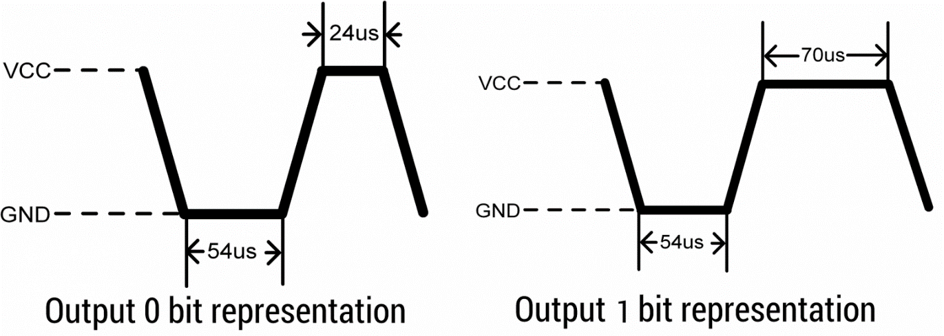
- After sending the response pulse, DHT11 sensor sends the data, which contains humidity and temperature value along with checksum.
- The data frame is of total 40 bits long, it contains 5 segments (byte) and each segment is 8-bit long.
- In these 5 segments, first two segments contain humidity value in decimal integer form. This value gives us Relative Percentage Humidity. 1st 8-bits are integer part and next 8 bits are fractional part.
- Next two segments contain temperature value in decimal integer form. This value gives us temperature in Celsius form.
- Last segment is the checksum which holds checksum of first four segments.
- Here checksum byte is direct addition of humidity and temperature value. And we can verify it, whether it is same as checksum value or not. If it is not equal, then there is some error in the received data.
- Once data received, DHT11 pin goes in low power consumption mode till next start pulse.
End of frame
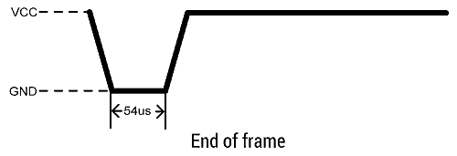
- After sending 40-bit data, DHT11 sensor sends 54us low level and then goes high. After this DHT11 goes in sleep mode.

DHT11 vs DHT22
Two versions of the DHT sensor, they look a bit similar and have the same pinout, but have different characteristics and specifications:
DHT11
- Ultra-low cost
- 3 to 5V power and I/O
- 2.5mA max current use during conversion (while requesting data)
- Good for 20-80% humidity readings with 5% accuracy
- Good for 0-50°C temperature readings ±2°C accuracy
- No more than 1 Hz sampling rate (once every second)
- Body size 15.5mm x 12mm x 5.5mm
- 4 pins with 0.1" spacin
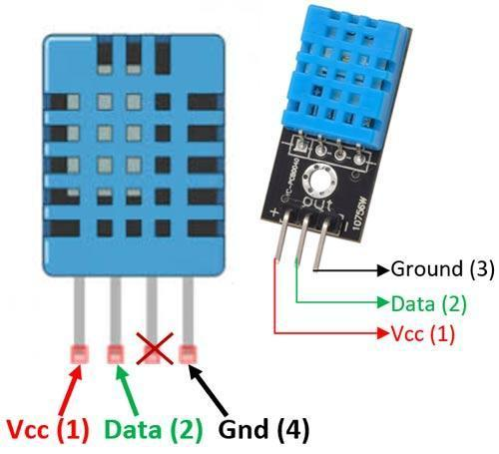
Fig. DHT11 and DHT22

Applications
This sensor is used in various applications such as measuring humidity and temperature values in heating, ventilation and air conditioning systems. Weather stations also use these sensors to predict weather conditions. The humidity sensor is used as a preventive measure in homes where people are affected by humidity. Offices, car museums,greenhouses and industries use this sensor for measuring humidity values and as a safety measure.
ULTRASONIC SENSOR
Ultrasonic sensors measure distance by using ultrasonic waves.The sensor head emits an ultrasonic wave and receives the wave reflected back from the target. Ultrasonic Sensors measure the distance to the target by measuring the time between the emission and reception
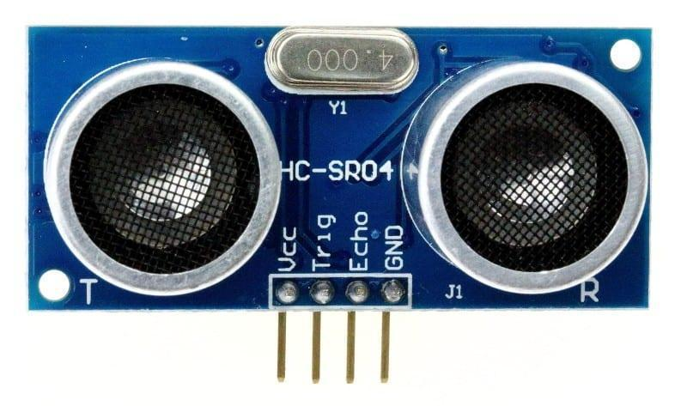
Fig. Ultrasonic sensor

An optical sensor has a transmitter and receiver, whereas an ultrasonic sensor uses a single ultrasonic element for both emission and reception. In a reflective model ultrasonic sensor, a single oscillator emits and receives ultrasonic waves alternately. This enables miniaturization of the sensor head.
HC-SR04 Ultrasonic Sensor – Working
As shown above the HC-SR04 Ultrasonic (US) sensor is a 4 pin module, whose pin names are Vcc, Trigger, Echo and Ground respectively. This sensor is a very popular sensor used in many applications where measuring distance or sensing objects are required. The module has two eyes like projects in the front which forms the Ultrasonic transmitter and Receiver. The sensor works with the simple high school formula that
Distance = Speed × Time
The Ultrasonic transmitter transmits an ultrasonic wave, this wave travels in air and when it gets objected by any material it gets reflected back toward the sensor this reflected wave is observed by the Ultrasonic receiver module as shown in the picture below
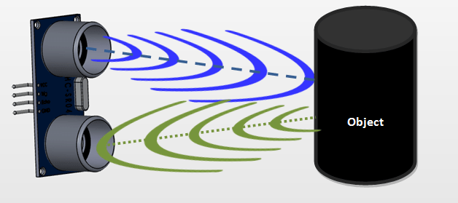
Now, to calculate the distance using the above formulae, we should know the Speed and time. Since we are using the Ultrasonic wave we know the universal speed of US wave at room conditions which is 330m/s. The circuitry inbuilt on the module will calculate the time taken for the US wave to come back and turns on the echo pin high for that same particular amount of time, this way we can also know the time taken. Now simply calculate the distance using a microcontroller or microprocessor.
How to use the HC-SR04 Ultrasonic Sensor
HC-SR04 distance sensor is commonly used with both microcontroller and microprocessor platforms like Arduino, ARM, PIC, Raspberry Pie etc. The following guide is universally since it has to be followed irrespective of the type of computational device used.

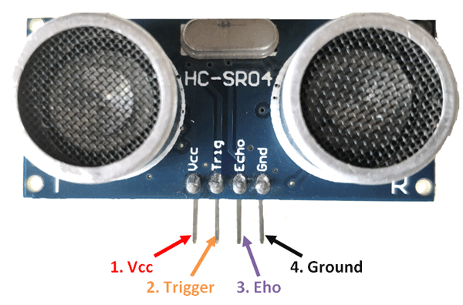
Fig.HS-SRO4 Ultrasonic Sensor
Power the Sensor using a regulated +5V through the Vcc ad Ground pins of the sensor. The current consumed by the sensor is less than 15mA and hence can be directly powered by the on board 5V pins (If available). The Trigger and the Echo pins are both I/O pins and hence they can be connected to I/O pins of the microcontroller. To start the measurement, the trigger pin has to be made high for 10uS and then turned off. This action will trigger an ultrasonic wave at frequency of 40Hz from the transmitter and the receiver will wait for the wave to return. Once the wave is returned after it getting reflected by any object the Echo pin goes high for a particular amount of time which will be equal to the time taken for the wave to return back to the sensor.The amount of time during which the Echo pin stays high is measured by the MCU/MPU as it gives the information about the time taken for the wave to return back to the Sensor. Using this information the distance is measured as explained in the above heading.
Ultrasonic Sensor Pin Configuration
Pin Number | Pin Name | Description
1 | Vcc | The Vcc pin powers the sensor, typically with +5V
2 | Trigger | Trigger pin is an Input pin. This pin has to be kept high for 10us to initialize measurement by sending US wave.
3 | Echo | Echo pin is an Output pin. This pin goes high for a period of time which will be equal to the time taken for the US wave to return back to the sensor.
4 | Ground | This pin is connected to the Ground of the system.
HC-SR04 Sensor Features
- Operating voltage: +5V
- Theoretical Measuring Distance: 2cm to 450cm
- Practical Measuring Distance: 2cm to 80cm
- Accuracy: 3mm
- Measuring angle covered: <15°
- Operating Current: <15mA
- Operating Frequency: 40Hz
Applications
- Used to avoid and detect obstacles with robots like biped robot, obstacle avoider robot, path finding robot etc.
- Used to measure the distance within a wide range of 2cm to 400cm Can be used to map the objects surrounding the sensor by rotating it
- Depth of certain places like wells, pits etc can be measured since the waves can penetrate through water
BUZZER
A buzzer or beeper is an audio signalling device, which may be mechanical, electromechanical, or piezoelectric (piezo for short). Typical uses of buzzers and beepers include alarm devices, timers, and confirmation of user input such as a mouse click or keystroke
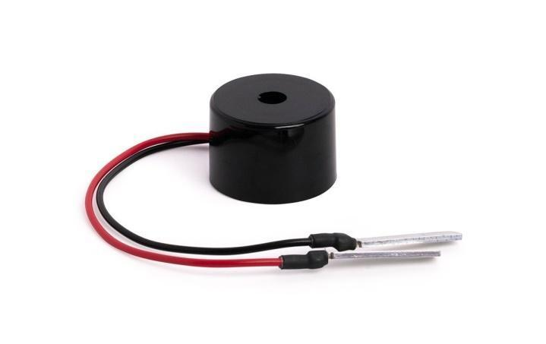
Fig.Buzzer
How to use a Buzzer
A buzzer is a small yet efficient component to add sound features to our project/system. It is very small and compact 2-pin structure hence can be easily used on breadboard, Perf Board and even on PCBs which makes this a widely used component in most electronic applications. There are two types are buzzers that are commonly available. The one shown here is a simple buzzer which when powered will make a Continuous Beeeeeeppp.... sound, the other type is called a readymade buzzer which will look bulkier than this and will produce a Beep. Beep. Beep. Sound due to the internal oscillating circuit present inside it. But, the one shown here is most widely used because it can be customised with help of other circuits to fit easily in our application. This buzzer can be used by simply powering it using a DC power supply ranging from 4V to 9V. A simple 9V battery can also be used, but it is recommended to use a regulated +5V or +6V DC supply. The buzzer is normally associated with a switching circuit to turn ON or turn OFF the buzzer at required time and require interval.
Types
Electromechanical
Early devices were based on an electromechanical system identical to an electric bell without the metal gong. Similarly, a relay may be connected to interrupt its own actuating current, causing the contacts to buzz. Often these units were anchored to a wall or ceiling to use it as a sounding board. The word "buzzer" comes from the rasping noise that electromechanical buzzers made.
Mechanical
A joy buzzer is an example of a purely mechanical buzzer and they require drivers. Other examples of them are doorbells.
Piezoelectric sensor
A piezoelectric element may be driven by an oscillating electronic circuit or other audio signal source, driven with a piezoelectric audio amplifier. Sounds commonly used to indicate that a button has been pressed are a click, a ring or a beep.
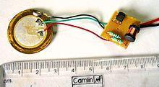
Fig. Piezoelectric sensor
Interior of a readymade loudspeaker, showing a piezoelectric-disk-beeper (With 3 electrodes ... including 1 feedback-electrode (the central, small electrode joined with red wire in this photo), and an oscillator to self-drive the buzzer.
A piezoelectric buzzer/beeper also depends on acoustic cavity resonance or Helmholtz resonance to produce an audible beep
Buzzer Pin Configuration
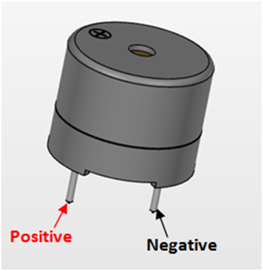
Fig .Buzzer Pin
Pin Number | Pin Name | Description
1 | Positive | Identified by (+) symbol or longer terminal lead. Can be powered by 6V DC
2 | Negative | Identified by short terminal lead. Typically connected to the ground of the circuit
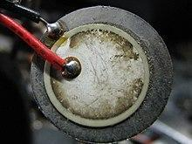
Fig. Piezoelectric

Specifications
- Rated Voltage: 6V DC
- Operating Voltage: 4-8V DC
- Rated current: <30mA
- Sound Type: Continuous Beep
- Resonant Frequency: ~2300 Hz
- Small and neat sealed package
- Breadboard and Perf board friendly

Application
- Alarming Circuits, where the user has to be alarmed about something
- Communication equipment’s
- Automobile electronics
- Portable equipment’s, due to its compact size.
Arduino is a popular choice for implementing smart farming solutions with IoT (Internet of Things) technology. Here's a basic outline of how you can use Arduino for smart farming:
1. Sensor Integration: Arduino boards can interface with various sensors such as soil moisture sensors, temperature and humidity sensors, light sensors, etc. These sensors provide real-time data about environmental conditions in the farm.
2. Data Acquisition: Arduino collects data from the sensors and processes it. This data can include soil moisture levels, temperature, humidity, light intensity, and even data from connected actuators like pumps or valves.
3. Connectivity: Arduino can be connected to the internet via Wi-Fi, Ethernet, or GSM modules. This enables the transfer of data to a central server or cloud platform where it can b further analyzed.
4. Data Analysis: The collected data can be analyzed to gain insights into the farm's conditions. For example, analyzing soil moisture data can help in efficient irrigation scheduling, while temperature and humidity data can assist in climate control within greenhouses.
5. Automation: Based on the analyzed data, Arduino can control actuators such as irrigation systems, fans, or heaters to automate various tasks on the farm. For instance, it can automatically water the crops when soil moisture levels drop below a certain threshold.
6. Remote Monitoring and Control: With IoT connectivity, farmers can monitor and control the farm remotely using smartphones or computers. They can receive alerts and notifications about critical conditions such as water leaks or sudden temperature changes.
7. Scalability: Arduino-based smart farming solutions can be easily scaled up or down based on the size of the farm and specific requirements. Additional sensors and actuators can be added as needed to monitor and control different aspects of the farm.
8. Low-Cost Solutions: Arduino boards and sensors are relatively inexpensive compared to proprietary IoT solutions, making them accessible to small-scale farmers or hobbyists. Overall, Arduino provides a flexible and cost-effective platform for implementing smart farming solutions, enabling farmers to improve efficiency, optimize resource usage, and increase yields.
Tabs, Multiple Files, and Compilation
Allows you to manage sketches with more than one file (each of which appears in its own tab). These can be normal Arduino code files (no visible extension), C files (.c extension), C++ files (.cpp), or header files (.h).
Uploading
Before uploading your sketch, you need to select the correct items from the Tools > Board and Tools > Port menus. The boards are described below. On the Mac, the serial port is probably something like /dev/tty.usbmodem241 (for an Uno or Mega2560 or Leonardo) or /dev/tty.usbserial-1B1 (for a Duemilanove or earlier USB board), or /dev/tty.USA19QW1b1P1.1 (for a serial board connected with a Keyspan USB-to-Serial adapter). On Windows, it's probably COM1 or COM2 (for a serial board) or COM4, COM5, COM7, or higher (for a USB board) - to find out, you look for USB serial device in the ports section of the Windows Device Manager. On Linux, it should be /dev/ttyACMx , /dev/ttyUSBx or similar. Once you've selected the correct serial port and board, press the upload button in the toolbar or select the Upload item from the Sketch menu. Current Arduino boards will reset automatically and begin the upload. With older boards (pre-Diecimila) that lack auto-reset, you'll need to press the reset button on the board just before starting the upload. On most boards, you'll see the RX and TX LEDs blink as the sketch is uploaded. The Arduino Software (IDE) will display a message when the upload is complete, or show an error.
When you upload a sketch, you're using the Arduino bootloader, a small program that has been loaded on to the microcontroller on your board. It allows you to upload code without using any additional hardware. The bootloader is active for a few seconds when the board resets; then it starts whichever sketch was most recently uploaded to the microcontroller. The bootloader will blink the on-board (pin 13) LED when it starts (i.e. when the board resets).
Libraries
Libraries provide extra functionality for use in sketches, e.g. working with hardware or manipulating data. To use a library in a sketch, select it from the Sketch > Import Library menu. This will insert one or more #include statements at the top of the sketch and compile the library with your sketch. Because libraries are uploaded to the board with your sketch, they increase the amount of space it takes up. If a sketch no longer needs a library, simply delete its #includestatements from the top of your code.
There is a list of libraries in the reference. Some libraries are included with the Arduino software. Others can be downloaded from a variety of sources or through the Library Manager. Starting with version 1.0.5 of the IDE, you do can import a library from a zip file and use it in an open sketch. See these instructions for installing a third-party library.
To write your own library, see this tutorial.
Third-Party Hardware
Support for third-party hardware can be added to the hardware directory of your sketchbook directory. Platforms installed there may include board definitions (which appear in the board menu), core libraries, bootloaders, and programmer definitions. To install, create the hardware directory, then unzip the third-party platform into its own sub-directory. (Don't use "arduino" as the sub-directory name or you'll override the built-in Arduino platform.) To uninstall, simply delete its directory.
For details on creating packages for third-party hardware, see the Arduino IDE 1.5 3rd party Hardware specification.
Serial Monitor
Displays serial data being sent from the Arduino or Genuino board (USB or serial board). To send data to the board, enter text and click on the "send" button or press enter. Choose the baud rate from the drop-down that matches the rate passed to Serial.begin in your sketch. Note that on Windows, Mac or Linux, the Arduino or Genuino board will reset (rerun your sketch execution to the beginning) when you connect with the serial monitor.
You can also talk to the board from Processing, Flash, MaxMSP, etc (see the interfacing page for details).
Preferences
Some preferences can be set in the preferences dialog (found under the Arduino menu on the Mac, or File on Windows and Linux). The rest can be found in the preferences file, whose location is shown in the preference dialog.
Language Support
Since version 1.0.1 , the Arduino Software (IDE) has been translated into 30+ different languages. By default, the IDE loads in the language selected by your operating system. (Note: on Windows and possibly Linux, this is determined by the locale setting which controls currency and date formats, not by the language the operating system is displayed in.)
If you would like to change the language manually, start the Arduino Software (IDE) and open the Preferences window. Next to the Editor Language there is a dropdown menu of currently supported languages. Select your preferred language from the menu, and restart the software to use the selected language. If your operating system language is not supported, the Arduino Software (IDE) will default to English.
You can return the software to its default setting of selecting its language based on your operating system by selecting System Default from the Editor Language drop-down. This setting will take effect when you restart the Arduino Software (IDE). Similarly, after changing your operating system's settings, you must restart the Arduino Software (IDE) to update it to the new default language.
Boards
The board selection has two effects: it sets the parameters (e.g. CPU speed and baud rate) used when compiling and uploading sketches; and sets and the file and fuse settings used by the burn bootloader command. Some of the board definitions differ only in the latter, so even if you've been uploading successfully with a particular selection you'll want to check it before burning the bootloader. You can find a comparison table between the various boards here.
Arduino Software (IDE) includes the built in support for the boards in the following list, all based on the AVR Core. The Boards Manager included in the standard installation allows to add support for the growing number of new boards based on different cores like Arduino Due, Arduino Zero, Edison, Galileo and so on.
• Arduino Yùn
An ATmega32u4 running at 16 MHz with auto-reset, 12 Analog In, 20 Digital I/O and 7 PWM.
• Arduino/Genuino Uno
An ATmega328 running at 16 MHz with auto-reset, 6 Analog In, 14 Digital I/O and 6 PWM.
• Arduino Diecimila or Duemilanove w/ ATmega168
An ATmega168 running at 16 MHz with auto-reset.
• Arduino Nano w/ ATmega328
An ATmega328 running at 16 MHz with auto-reset. Has eight analog inputs.
• Arduino/Genuino Mega 2560
An ATmega2560 running at 16 MHz with auto-reset, 16 Analog In, 54 Digital I/O and 15 PWM.
• Arduino Mega
An ATmega1280 running at 16 MHz with auto-reset, 16 Analog In, 54 Digital I/O and 15 PWM.
• Arduino Mega ADK
An ATmega2560 running at 16 MHz with auto-reset, 16 Analog In, 54 Digital I/O and 15 PWM.
• Arduino Leonardo
An ATmega32u4 running at 16 MHz with auto-reset, 12 Analog In, 20 Digital I/O and 7 PWM.
• Arduino/Genuino Micro
An ATmega32u4 running at 16 MHz with auto-reset, 12 Analog In, 20 Digital I/O and 7 PWM.
• Arduino Esplora
An ATmega32u4 running at 16 MHz with auto-reset.
• Arduino Mini w/ ATmega328
An ATmega328 running at 16 MHz with auto-reset, 8 Analog In, 14 Digital I/O and 6 PWM.
• Arduino Ethernet
Equivalent to Arduino UNO with an Ethernet shield: An ATmega328 running at 16 MHz with auto-reset, 6 Analog In, 14 Digital I/O and 6 PWM.
• Arduino Fio
An ATmega328 running at 8 MHz with auto-reset. Equivalent to Arduino Pro or Pro Mini (3.3V, 8 MHz) w/ ATmega328, 6 Analog In, 14 Digital I/O and 6 PWM.
• Arduino BT w/ ATmega328
ATmega328 running at 16 MHz. The bootloader burned (4 KB) includes codes to initialize the on-board bluetooth module, 6 Analog In, 14 Digital I/O and 6 PWM..
• LilyPad Arduino USB
An ATmega32u4 running at 8 MHz with auto-reset, 4 Analog In, 9 Digital I/O and 4 PWM.
• LilyPad Arduino
An ATmega168 or ATmega132 running at 8 MHz with auto-reset, 6 Analog In, 14 Digital I/O and 6 PWM.
• Arduino Pro or Pro Mini (5V, 16 MHz) w/ ATmega328
An ATmega328 running at 16 MHz with auto-reset. Equivalent to Arduino Demilune or Nano w/ ATmega328; 6 Analog In, 14 Digital I/O and 6 PWM.
• Arduino NG or older w/ ATmega168
An ATmega168 running at 16 MHz without auto-reset. Compilation and upload is equivalent to Arduino Diecimila or Duemilanove w/ ATmega168, but the bootloader burned has a slower timeout (and blinks the pin 13 LED three times on reset); 6 Analog In, 14 Digital I/O and 6 PWM.
• Arduino Robot Control
An ATmega328 running at 16 MHz with auto-reset.
• Arduino Robot Motor
An ATmega328 running at 16 MHz with auto-reset.
• Arduino Gemma
An ATtiny85 running at 8 MHz with auto-reset, 1 Analog In, 3 Digital I/O and 2 PWM.

Working Principle
The working principle of smart farming using IoT involves the integration of Internet of Things (IoT) technology into agricultural practices to monitor, manage, and optimize various aspects of farming operations. Here's a breakdown of the key components and the working principle:
1. Sensors and Actuators: IoT devices such as sensors and actuators are deployed throughout the farm to collect data and perform actions. These sensors can measure parameters such as soil moisture, temperature, humidity, light intensity, pH level, and nutrient levels. Actuators, on the other hand, can control irrigation systems, machinery, and other farm equipment.
2. Data Collection: The sensors continuously collect data from the farm environment. This data is typically transmitted wirelessly to a central hub or cloud-based platform for processing and analysis. The sensors may communicate using various wireless protocols such as Wi-Fi, Bluetooth, LoRa, or Zigbee.
3. Data Analysis and Decision Making: In the cloud-based platform, sophisticated algorithms analyse the collected data in real-time to derive meaningful insights. Machine learning and data analytics techniques are often employed to identify patterns, trends, and anomalies in the data. Based on this analysis, the system can make informed decisions and generate actionable recommendations for farmers.
4. Remote Monitoring and Control: Farmers can remotely monitor and control farm operations through web-based dashboards or mobile applications. These interfaces provide real-time access to sensor data, analytics results, and control options. Farmers can adjust irrigation schedules, monitor crop health, detect pest infestations, and manage other aspects of their farm from anywhere with an internet connection.
5. Automation and Optimization: Smart farming systems can automate routine tasks and optimize resource usage based on the insights gained from data analysis. For example, automated irrigation systems can adjust water flow based on soil moisture levels, minimizing water wastage while ensuring optimal plant growth. Similarly, predictive maintenance algorithms can schedule equipment repairs before failures occur, reducing downtime and maintenance costs.
6. Integration with External Systems: Smart farming systems can also integrate with external data sources such as weather forecasts, market prices, and supply chain logistics. By incorporating this additional information, farmers can make more informed decisions about planting schedules, harvesting times, and market strategies.

FUTURE WORK
Enhanced Sensor Integration: Explore the integration of additional sensors to monitor additional parameters relevant to crop growth, such as humidity, nutrient levels, and atmospheric gases, providing a more comprehensive understanding of environmental conditions.
Data Analytics and Predictive Modeling: Implement data analytics techniques and predictive modeling algorithms to analyze historical data and predict optimal conditions for crop growth, enabling proactive decision-making and resource allocation.
Integration with Weather Forecasting Systems: Integrate the farming system with weather forecasting systems to incorporate real-time weather data into decision-making processes, enabling farmers to anticipate and mitigate the impact of adverse weather conditions on crop growth.
Precision Irrigation and Fertilization: Develop algorithms for precision irrigation and fertilization based on sensor data and environmental conditions, optimizing resource usage and minimizing environmental impact while maximizing crop yield.

Chapter-8

Automation function by Sensor
Conditions:
Temperature Sensor
Optimum temperature: 30 Degree C
Minimum temperature:
13 to 27 Degree C Email alert if temperature rises above 30 Degree C or drop below 10 Degree C
Soil Moisture Sensor
Optimum water content: 60 %
Email alert if it goes above 60% or below 55%
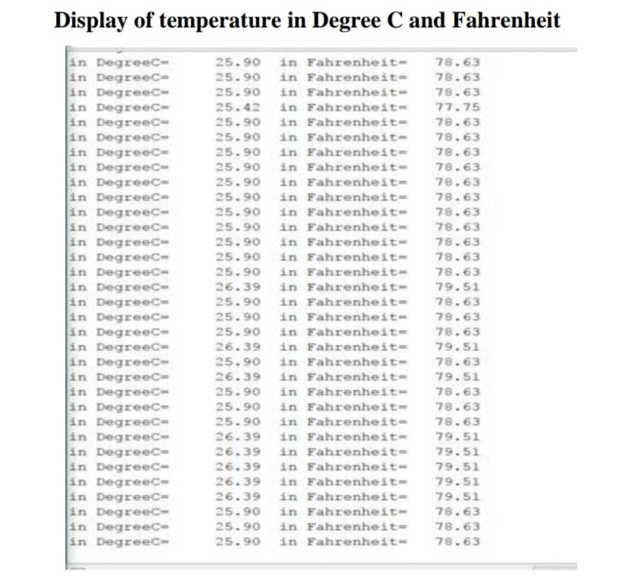

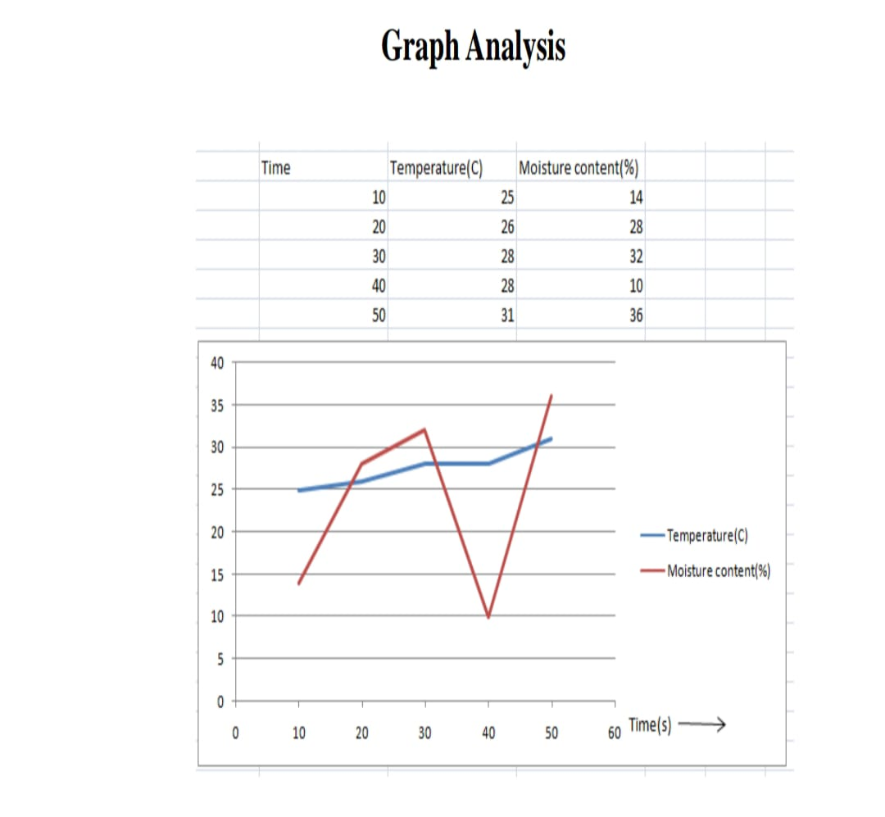
Fig. Graph of two sensors
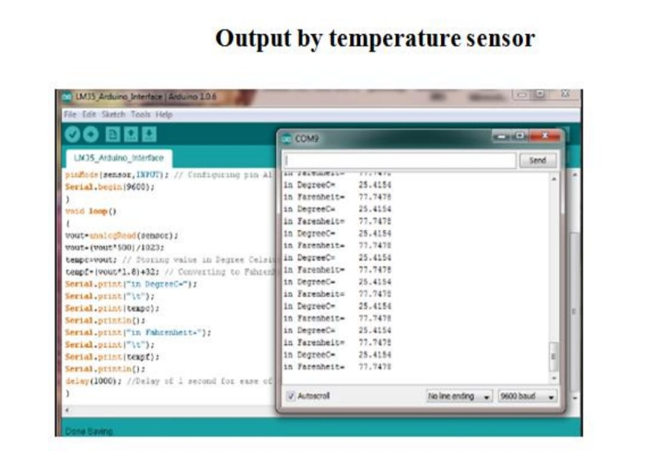
Fig. Output by temperature sensor
The above graph illustrate the two data set i.e Temperature(C) and moisture(%) in given interval of 10 s. The maximum value of temperature is 31 degree C and maximum value of soil moisture content 36%. Fig..20 graph of two sensors 29 . f we will come to know the changes of temperature and soil moisture with respect to time. For example soil moisture content start from 15% and increases rapidly till 32% and decreasing down to 10%. The zig-zag movement of slope shows the how many water the particular crop is having or not. From there we know when to water and when to pump out the water. The slope of temperature doesn’t change much since temperature changes slowly. If graph value of slope (red) is very low, we should immediately water the plants and vice versa. Is the output displayed by Arduino Software, Is output displayed from soil moisture sensors is output displayed from temperature sensor that we have used.

Chapter- 9

CONCLUSION

The Smart Farming System represents a transformative leap in agricultural practices, leveraging advanced sensor technologies, IoT integration, and automation to optimize crop growth conditions. Through precise monitoring of critical parameters and remote accessibility, it offers a proactive solution to the challenges faced by traditional farming methods. By enabling timely interventions, efficient resource utilization, and data-driven decision-making, this system not only enhances crop yield but also contributes towards sustainable and smarter farming practices. Its potential to revolutionize farm management underscores its significance in ensuring food security while promoting efficiency and sustainability in agriculture. In conclusion, the implementation of Smart Farming Systems utilizing IoT represents a pivotal advancement in modern agriculture, promising a paradigm shift towards more efficient, sustainable, and resilient farming practices. By seamlessly integrating cutting-edge sensor technologies, IoT connectivity, and automation, this innovative approach empowers farmers with real-time insights and actionable data, enabling them to make informed decisions and optimize crop growth conditions like never before .The transformative potential of Smart Farming extends far beyond mere yield optimization; it fundamentally redefines the way we perceive and engage with agriculture. Through precise monitoring of crucial parameters such as soil moisture, temperature, humidity, and crop health, farmers can proactively address challenges, mitigate risks, and maximize resource efficiency. This proactive stance not only enhances productivity and profitability but also reduces environmental impact by minimizing wastage and optimizing resource utilization. Moreover, the remote accessibility feature of Smart Farming Systems offers unprecedented flexibility and control, allowing farmers to manage their operations from anywhere, at any time. This aspect is particularly crucial in today's fast-paced world, where demands on farmers are ever-evolving, and timely interventions can make all the difference between success and failure.
Furthermore, by embracing Smart Farming technologies, agricultural communities can foster greater sustainability, resilience, and food security in the face of growing global challenges such as climate change, resource scarcity, and population growth. By leveraging data-driven insights and advanced analytics, farmers can adapt to changing conditions more effectively, minimize risks, and optimize yields sustainably. In essence, Smart Farming using IoT represents not just a technological innovation but a holistic approach towards reimagining agriculture for the 21st century. Its ability to enhance productivity, sustainability, and resilience underscores its significance in shaping the future of farming, ensuring food security, and fostering a more prosperous and sustainable world for generations to come.

REFERENCE
[1] T. Folnovic, Loss of Arable Land Threaten World Food inventories. Available 1467 https//blog.agrivi.com 1468
[2] O. Calicioglu,A. Flammini,S. Bracco,L . Bellù, and R. Sims, ‘‘ The unborn 1469 challenges of food and husbandry An intertwined analysis of trends and 1470 results, ’’ Sustainability,vol. 11,no. 1,p. 222, 2019. 1471
[3] D.K. Ray,N.D. Mueller,P.C. West, andJ.A. Foley, ‘‘ Yield trends are 1472 inadequate to double global crop product by 2050, ’’ PLoS ONE,vol. 8, 1473 no. 6, 2013, Art. no. e66428. 1474
[4] G.N. Tiwari, Greenhouse Technology for Controlled Environment. 1475 Oxford,U.K. Alpha Science Int. ’ l Ltd, 2003. 1476
[5] literal Background of glasshouses. Emerald Agr.Technol., 1477 Kolhapur, India. penetrated May 1, 2021(Online). Available 1478 http//www.emerald-agri.com 1479
[6] S. Vatari,A. Bakshi, andT. Thakur, ‘‘Green house by using IoT and 1480 pall computing, ’’ in Proc. IEEE Int. Conf. Recent TrendsElectron., Inf. 1481 Commun. Technol.(RTEICT), May 2016,pp. 246 – 250. 1482
[7] S. El- Gayar,A. Negm, andM. Abdrabbo, ‘‘ hothouse operation and 1483 operation in Egypt, ’’ in Conventional Water coffers and Agricul- 1484 ture in Egypt. Cham, Switzerland Springer, 2018,pp. 489 – 560. 1485
[8] I.L. López- Cruz,E. Fitz- Rodríguez,R. Salazar- Moreno,A. Rojano- 1486 Aguilar, andM. Kacira, ‘‘ Development and analysis of dynamical calculation- 1487 ematical models of hothouse climate A review, ’’ Eur.J. Hortic.Sci., 1488 vol. 83,pp. 269 – 280,Oct. 2018. 1489
[9] N. Gruda, ‘‘ Current and unborn perspective of growing media in Europe, ’’ 1490 in Proc. 5th Balkan Symp. Vegetables Potatoes,vol. 960,Oct. 2011, 1491 pp. 37 – 43. 1492
[10] R. Dagar,S. Som, andS.K. Khatri, ‘‘ Smart husbandry- IoT in husbandry, ’’ 1493 in Proc. Int. Conf. Inventive Res. Comput. Appl.( ICIRCA),Jul. 2018, 1494 pp. 1052 – 1056. 1495
[11] S. Ratnaparkhi etal., ‘‘ Smart husbandry detectors in IOT A review, ’’ 1496 mammy. moment,Proc.,vol. 46,no. 18,pp. 1 – 6, 2020. 1497
[12] E.M. Gross,B.P. Lahkar,N. Subedi,V.R. Nyirenda,L.L. Lichtenfeld, 1498 andO. Jakoby, ‘‘ Seasonality, crop type and crop phenology influence 1499 crop damage by wildlife beasties in Africa and Asia, ’’ Biodiversity 1500 Conservation,vol. 27,no. 8,pp. 2029 – 2050, 2018. 1501
[13] M.R . Conover,E. Butikofer, andD.J. Decker, ‘‘ Wildlife damage to crops 1502 comprehensions of agrarian and wildlife leaders in 1957, 1987, and 2017, ’’ 1503 WildlifeSoc.Bull.,vol. 42,no. 4,pp. 551 – 558, 2018. 1504
[14] R.K. Lova andV. Vijayaraghavan, ‘‘IoT technologies in agrarian 1505 terrain A check, ’’ Wireless Pers.Commun.,vol. 113,no. 4, 1506 pp. 2415 – 2446, 2020. 1507
[15] I.F.M. Ullah,M. Aman, andD. Kim, ‘‘An optimization scheme for IoT 1508 grounded smart hothouse climate control with effective energy consump- 1509 tion,’’Computing,vol. 104,no. 2,pp. 433 – 457, 2022. 1510
[16] A. Khudoyberdiev andI.D.U. Kim, ‘‘ Optimization- supported water drag- 1511 plement medium with energy effectiveness in IoT grounded hothouse, ’’ 1512 J. Intell. FuzzySyst.,vol. 40,no. 5,pp. 10163 – 10182, 2021. 1513
[17] A.P. Antony,K. Leith,C. Jolley,J. Lu, andD.J. Sweeney, ‘‘ A review 1514 of practice and perpetration of the Internet of effects( IoT) for small- 1515 holder husbandry, ’’ Sustainability,vol. 12,no. 9,p. 3750, 2020. 1516
[18] Y. Mekonnen,S. Namuduri,L. Burton,A. Sarwat, andS. Bhansali, 1517 ‘‘Machine literacy ways in wireless detector network grounded pre- 1518 cision husbandry, ’’J. Electrochem.Soc.,vol. 167,no. 3, 2019, 2019, 1519 Art.no. 037522. 1520
[19] A. Sharma,A. Jain,P. Gupta, andV. Chowdary, ‘‘Machine learning 1521 operations for perfection husbandry A comprehensive review, ’’ IEEE 1522 Access,vol. 9,pp. 4843 – 4873, 2020. 1523
[20] R. Akhter andS.A. Sofi, ‘‘ Precision husbandry using IoT data analytics 1524 and machine literacy, ’’J. King SaudUniv.- Comput. Inf.Sci.,vol. 34, 1525 no. 8,pp. 5602 – 5618, 2021. 1526
[21]K. Bakthavatchalam,B. Karthik,V. Thiruvengadam,S. Muthal,D. Jose, 1527 K. Kotecha, andV. Varadarajan, ‘‘ IoT frame for dimension and 1528 perfection husbandry Predicting the crop using machine literacy algo- 1529 rithms, ’’ Technologies,vol. 10,no. 1,p. 13, 2022.
[22] M. C. T. Scholten, I. J. M. de Boer, B. Gremmen, and C. Lokhorst,‘‘Livestock farming with care: Towards sustainable production of animal-source food,’’ NJAS: Wageningen J. Life Sci., vol. 66, no. 1, pp. 3–5,Nov. 2013.
[23] M. Henchion, M. McCarthy, V. C. Resconi, and D. Troy, ‘‘Meat consumption: Trends and quality matters,’’ Meat Sci., vol. 98, no. 3, pp. 561–568,Nov. 2014.
[24] M. Bezabih, ‘‘Livestock and livestock products by 2050,’’ IJAR, vol. 4,p. 30, 2020.
[25] Y. Xiong, Q.-S. Meng, J. Gao, X.-F. Tang, and H.-F. Zhang, ‘‘Effects of relative humidity on animal health and welfare,’’ J. Integrative Agricult.,vol. 16, no. 8, pp. 1653–1658, Aug. 2017.
[26] D. Wu, D. Cui, M. Zhou, and Y. Ying, ‘‘Information perception in modern poultry farming: A review,’’ Comput. Electron. Agricult., vol. 199, Aug. 2022, Art. no. 107131.
Here are some references that you can consider for your smart farming project:

[27]Liakos, V., Busato, P., Moshou, D., Pearson, S., & Bochtis, D. (2018). Machine learning in agriculture: A review. Sensors, 18(8), 2674.
[28]Gubbi, J., Buyya, R., Marusic, S., & Palaniswami, M. (2013). Internet of Things (IoT): A vision, architectural elements, and future directions. Future Generation Computer Systems, 29(7), 1645-1660.
[29]Ortiz-Barredo, A., Testi, L., Orgaz, F., & Fereres, E. (2016). Assessment of unmanned aerial vehicles imagery for quantitative monitoring of wheat crop in small plots. Sensors, 16(9), 1467.
[30]Kussul, N., Lavreniuk, M., Skakun, S., & Shelestov, A. (2017). Deep learning classification of land cover and crop types using remote sensing data. IEEE Geoscience and Remote Sensing Letters, 14(5), 778-782.
[31]Liu, B., & Wang, J. (2018). Integration of Internet of Things and precision agriculture into rural tourism. Journal of Ambient Intelligence and Humanized Computing, 9(4), 1107-1119.
[32]Zeng, Y., Zhang, S., & Huang, G. (2017). Crop monitoring using internet of things and unmanned aerial vehicle. Journal of Applied Remote Sensing, 11(2), 026022.
[33]Patel, N. S., Tiku, S. N., & Patel, H. K. (2018). A review: Internet of Things (IoT) in agriculture. In 2018 3rd International Conference for Convergence in Technology (I2CT) (pp. 1-5). IEEE.
[34]Wang, H., Zhang, X., & Yang, Q. (2018). An improved crop yield prediction algorithm based on data mining and the Internet of Things. Sustainability, 10(10), 3661.
[35]Mishra, A., Alok, S., & Verma, A. K. (2017). Smart agriculture: IoT based greenhouse automation. In 2017 International Conference on Big Data Analytics and Computational Intelligence (ICBDAC) (pp. 27-30). IEEE.
[36]Patel, H., & Shah, S. (2016). IoT based smart agriculture monitoring system. In 2016 International Conference on Wireless Communications, Signal Processing and Networking (WiSPNET) (pp. 1732-1735). IEEE.

These references cover various aspects of smart farming, including IoT applications, crop monitoring, data analytics, and automation systems. They can serve as valuable resources for your project.

